1.1 I can describe the method skills and resources required to complete tasks successfully

**Macros**

A system that allows the user to effectively save time (on repetitive tasks), and allow the user to work faster and efficiently. The macro is used on frequently used tasks creating a series of commands and instructions.

**Steps**

**1.** From The top tool, bar select View and Macro. Here one would select Record Macro

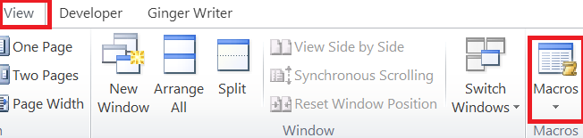

Fig 1

**2.** Under macro name type the name for the macro i.e ‘macro 1’. Here you can also add a description of the purpose of the macro and short cut.

Finally select the keyboard icon

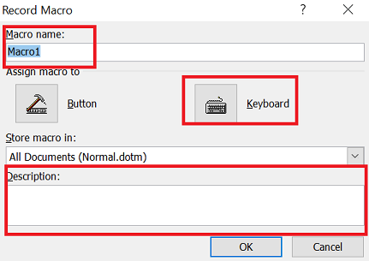

Fig 2

3. Assign short cut keys. Once assigned a prompt will appear indicating if the keys have been used previously, if not continue.

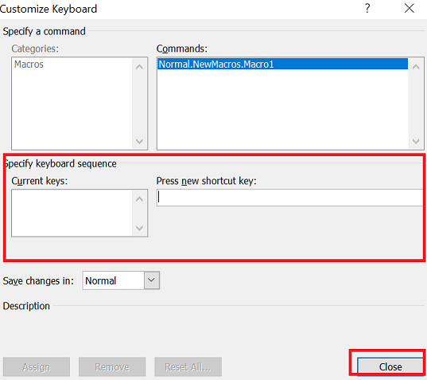

Fig 3

4. Record actions, such as highlighting a word, adding bold, and colour. So in the Text example below I want all my headings to be

* ariel font,
* font size of 14,
* underlined

5. Stop recording either via the macro tabs selecting ‘stop recording’ or select stop recording bottom of document

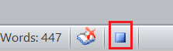

Fig 4

6. Run Macro, by selecting the appropriate word(s) and pressing the chosen short cut.

**Example Test-Running a macro**

Macro 2- Headings

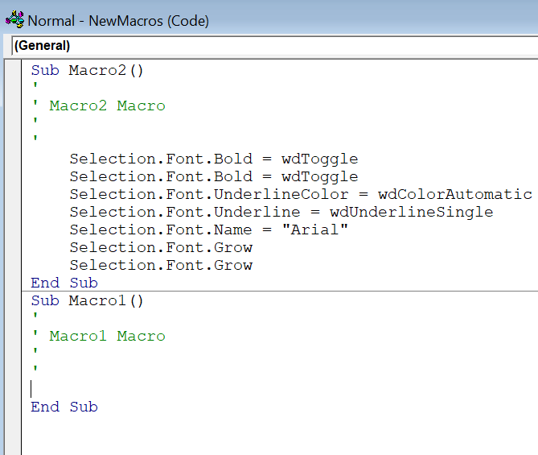

What are Newton’s law of Motion?

1. An object at rest remains at rest, and an object in motion remains in motion at constant speed and in a straight line unless acted on by an unbalanced force.
2. The acceleration of an object depends on the mass of the object and the amount of force applied.
3. Whenever one object exerts a force on another object, the second object exerts an equal and opposite on the first.

Sir Isaac Newton worked in many areas of mathematics and physics. He developed the theories of gravitation in 1666 when he was only 23 years old. In 1686, he presented his three laws of motion in the “Principia Mathematica Philosophiae Naturalis.”

By developing his three laws of motion, Newton revolutionized science. Newton’s laws together with Kepler’s Laws explained why planets move in elliptical orbits rather than in circles.

Newton’s Second Law: Force

The acceleration of an object depends on the mass of the object and the amount of force applied.

His second law defines a force to be equal to change in momentum (mass times velocity) per change in time. Momentum is defined to be the mass m of an object times its velocity V.

Newton’s Third Law: Action & Reaction

Whenever one object exerts a force on a second object, the second object exerts an equal and opposite force on the first.

His third law states that for every action (force) in nature there is an equal and opposite reaction. If object A exerts a force on object B, object B also exerts an equal and opposite force on object A. In other words, forces result from interactions.

End of example